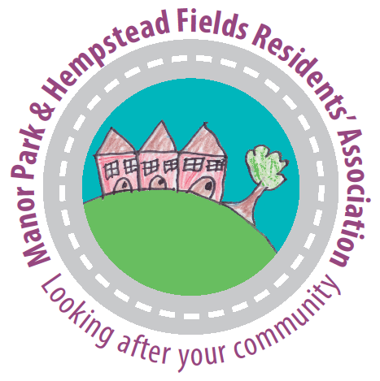

Manor Park and Hempstead Fields
Residents’ Association

Committee Meeting at 27 Roman Way

Wednesday 11th March 2015 at 7.30pm

NOTE 7.30 START

AGENDA

- Welcome and apologies for absence Paul

- Minutes of the last meeting and matters arising Paul

- Treasurer’s report Sally

- Surgery Car Service – update, issues, meeting, wheelchair users Peter

- Spring Newsletter – content and delivery arrangements Peter

- Walking Group launched Peter

- Neighbourhood Plan Steering Group, update Wendy

- TCR Project, pdate Paul/Peter

- Social media – stat’s, hot topics etc. Wendy & Peter

- Future events –
  - Easter Egg Hunt – arrangements, helpers please Peter
  - Big Lunch 2015 – combine with other Residents’ Groups? Peter
  - AGM in July - date? Speaker? (Trevor Weeks MBE WRAS?) Paul
  - Other ideas? All

- Any other business:

- Land at Oakwood Drive - Nigel Clark’s suggestion Peter
- Tesco – litter picking Dorothy
- Meet up again with other Residents’ Associations? Paul
- Churchcoombe trip to WW1 sites Peter

- Date, time and venue of next meeting

